
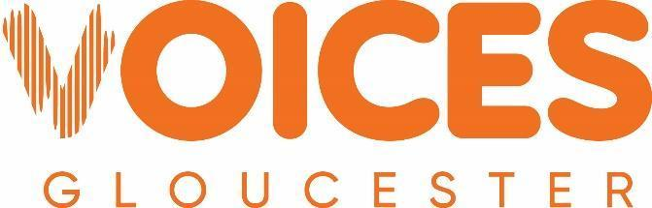

Date Received | VG Ref

Expression of Interest Form for Ukrainian Women’s Voices Project

Your name:
Names of any collaborators:
Place(s) you’re currently living:
What is your hometown?
When did you move to the UK?
Organisation connection (Voices Gloucester or JST)
Available to join an in-person residential in Scotland from 25th – 27th September?
Are you happy for your project details to be shared with other participants?
Consent to photos being shared for communication purposes
How would you evaluate your English?
Work place and position?
Email and/or WhatsApp contact:

This form is an expression of interest. Grants will either be distributed as 3 separate amounts of £3000 each, OR projects may be combined as a result of the project development residential, 25 - 27th September 2026

Project Details

- What is the name of your project?

- Please provide a summary of your project (a maximum of five lines).

- Please provide further detail about your project, to include;
- Whether you will be working with any other practitioners
- Who you hope to reach (in terms of audience/community engagement)
- What impact you imagine having through this project
- Where your project will take place
- What you hope to create
- How the project links to:
  - Arts, Culture and Heritage
  - Communication and Dialogue
  - Social Cohesion

- Why do you think this project is important?

- Project start date: Project end date:

- Please use the table below to show us how you would like to spend the money.

Example: Community workshops | 2 x artists days planning & delivery @ £250 | £500
 | TOTAL

- How much would you like to apply for from Voices Gloucester/ JST?

- Can we see examples of previous work? Please add links to website or social media, or include
examples of work with your application.

- Please share details of any additional support you are seeking, such as mentoring, coaching, communications support, specialist skills, access to networks, or project development advice

- (Optional) Please attach a photograph to your application email which best represents your project and you are happy to be used for marketing purposes should your application be successful. This could be a headshot of the project lead if preferred. Please provide the photographer credit below.

"Photo by [add Photographer's Name with link to website if you have it], [add Title of Photo if you have it]

Please send your form and any questions to: applications@jst.org

Deadline: 30/07/2026

